110.

CREATE OR REPLACE VIEW otlichniki AS SELECT * FROM student S WHERE NOT EXISTS(SELECT EM.STUDENT_ID FROM exam_marks EM WHERE S.STUDENT_ID=EM.STUDENT_ID AND EM.MARK IN (2,3,4)) AND (SELECT COUNT(*) FROM exam_marks WHERE exam_marks.STUDENT_ID=S.STUDENT_ID)<>0

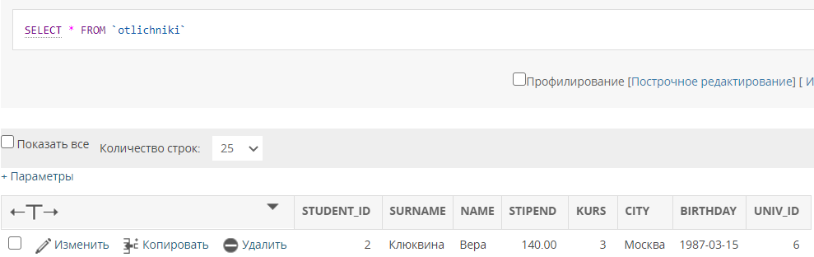

111.

CREATE VIEW stud_in_city AS SELECT S.CITY, COUNT(S.STUDENT_ID) FROM student S GROUP BY S.CITY

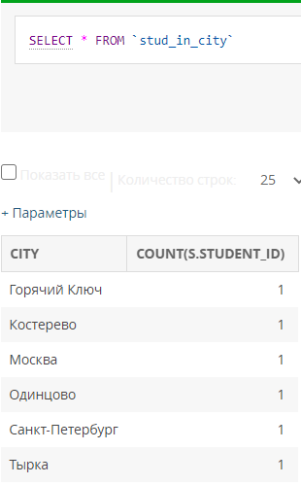

112.

CREATE VIEW stat_otchenki AS SELECT S.STUDENT_ID, S.SURNAME, S.NAME, AVG(MARK), SUM(MARK) FROM student S, exam_marks EM WHERE S.STUDENT_ID=EM.STUDENT_ID GROUP BY S.STUDENT_ID

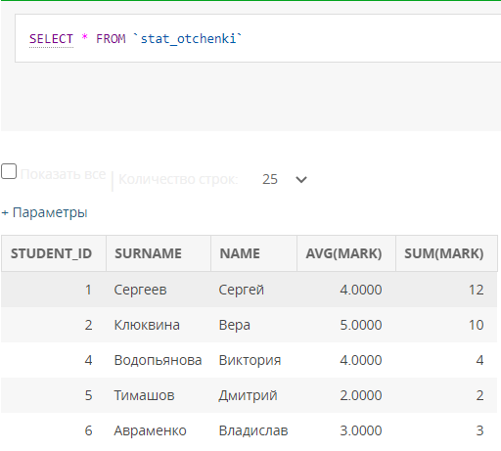

113.

CREATE VIEW stat_exam AS SELECT S.STUDENT_ID, S.SURNAME, S.NAME, COUNT(EM.EXAM_ID) FROM student S, exam_marks EM WHERE S.STUDENT_ID=EM.STUDENT_ID GROUP BY S.STUDENT_ID

